
ACTIVE LEARNING TEMPLATE: Growth and Development

STUDENT NAME

DEVELOPMENTAL STAGE PRESCHOOL REVIEW MODULE CHAPTER

EXPECTED GROWTH AND DEVELOPMENT


Physical | Cognitive | Psychological | Age- Appropriate
Physical | Cognitive | Development | Activities
Development | Development | Development | Activities

The child has |  | The thinking and
become very lean. |  | reasoning capacity of
become very lean. |  | the child has really
However he is |  | the child has really
However he is |  | developed. He/she
much stronger and |  | developed. He/she
much stronger and |  | knows, understand
tall (Snider, 2007). |  | knows, understand
tall (Snider, 2007). |  | and can differentiate
various colors and
count numbers and
letters. He can
recognize familiar
faces.
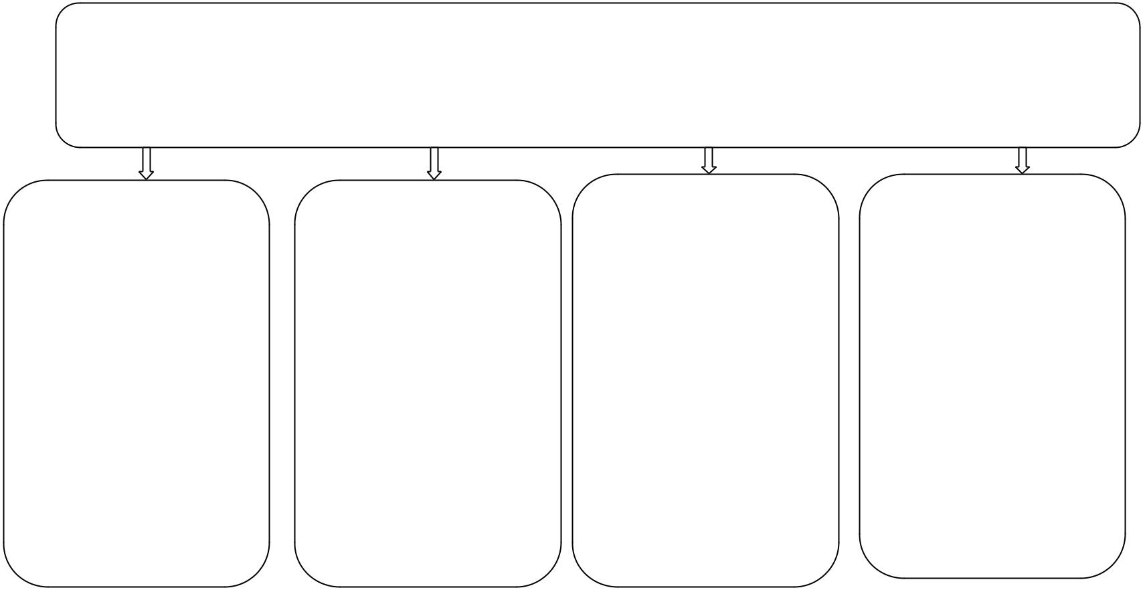

Health promotion

The child has the ability of managing his feelings. The child starts to develop friendships between peer groups and sees them as very integral part of his life. The understand right and wrong.

The age appropriate activities of the child at this age include block games, matching colors and sorting. These activities should arouse the child’s interest in learning.

Some health issues suffered by children during this period include biting thumb sucking and stuttering. These problems should be reported and checked by physician if they tend to persist (Onis, 2000).

 | Immunizations |  |  |  | Health Screening
 | All preschool |  |  |  | Blood pressure
 | students should be |  |  |  | should be screened
 | immunized against |  |  |  | for stability visual
 | diphtheria polio, |  |  |  | and hearing ability
 | NMR and viceria. All |  |  |  | should be screened
 | other |  |  |  | together with other
 | recommendation of |  |  |  | physical conditions.
 | immunizations as |  |  |  | Oral health and
 | stipulated by CDC |  |  |  | mental health is
 | must be adhered to. |  |  |  | important.

Nutrition

The nutrition should be checked for balance diet because at this age the child’s body is rapidly growing. The food has to suffer on a regular basis (Onis, 2000).

Injury Prevention

The child should be constantly monitored because of the destructive nature of the children at this age. The child should be away from harmful objects and blunt objects. A full time monitoring of child’s activities required.

ACTIVE LEARNING TEMPLATES THERAPEUTIC PROCEDURE A5

